

UNIVERSITY of LIMERICK

OLLSCOIL LUIMNIGH

COLLEGE OF INFORMATICS AND ELECTRONICS

DEPARTMENT OF MATHEMATICS & STATISTICS

END OF SEMESTER ASSESSMENT PAPER

MODULE CODE: MA4005 SEMESTER: REPEAT 2007

MODULE TITLE: Engineering Maths T1 DURATION OF EXAM: 2.5 hours

LECTURER: J. Leahy GRADING SCHEME:
Examination: 100%

EXTERNAL EXAMINER: Prof. J. King

INSTRUCTIONS TO CANDIDATES

Answer one question from each Section A and B and any three other questions – five questions in total. All questions carry equal marks
-2-

Engineering Maths T1

Marks
SECTION A

Q.1 (a) Find all second partial derivatives of the following functions

    - z = x²y – y²x
    - e^{xy} 8

- The area A of a parallelogram is calculated from the formula

A = absinC

using the measured values 3m, 7m and 30° for a, b and C
respectively. Find using partial differentiation the maximum
error in the area as calculated if there is a maximum error of 0.2cm
in the measurement of a and b and of 0.2° in the measurement of C. 12

Q.2 (a) Evaluate the integrals

(i) 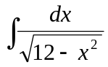 (ii) 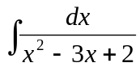 6

- Find the volumes generated when the area between the curve
y = x² and the x-axis from x = 0 to x = 1 is rotated about the
x-axis and the y-axis. 7

(c) Find the centre of gravity of the area in (b). 7

Q.3 (a) Find the general solutions of the differential equations

(i) 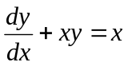 (ii) 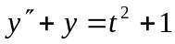 12

- A thin strut of length 2m is slightly bent by two equal forces P
applied at its ends. The resulting deflection satisfies the equation

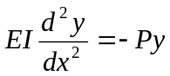

If 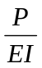is constant and greater than zero determine y as a function of x.
-3-

Engineering Maths T1

Marks

Find the value of P given that the boundary conditions are y = 0
at x = 0 and y = 0 at x = 2. 8

Q.4 (a) Calculate from the definition the Laplace transforms of the function

f(t) = e^{-3t} + 1 4

- Use the tables to find the Laplace transform of the functions

  - 5cosh3t – sin2t

(ii) f(t) = t² e^{3t} 4

- Find the inverse Laplace transform of the function

F(s) = 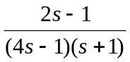 6

- Use the Laplace transform to find the solution of the boundary
value problem

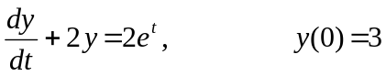 6

Q.5 Find the Fourier series of period 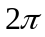 of the function

f(x) = 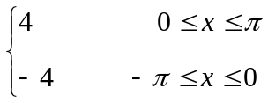 f(x) = f(x + 2π) 17

Use your answer to find an expression for . 3

-4-

Engineering Maths T1

Marks

SECTION B

Q.6 (a) Prove abc is a factor of the determinant

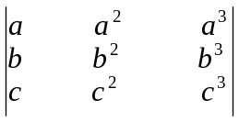 3

- Show the system of linear equations

x + y + z = 1
2x – 3y + 2z = -3
4x – y + 4z = -1

has an infinite number of solutions and find two solutions. 7

- Find the inverse of the matrix

A = 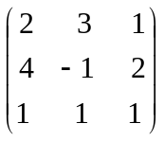 5

and hence solve the system

2x + 3y + z = 9
4x – y + 2z = 4
x + y + z = 4 5

Q.7 (a) Define a vector space 4

- Show the set of all 2 x 2 matrices with real entries together
with the operations of matrix addition and scalar multiplication
is a vector space. 4

(c) Show the vectors 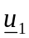= (1,0,3), 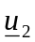= (0,-1,4) and 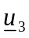= (2,3,0) are
linearly independent in R³. 6

-5-

Engineering Maths T1

Marks

- Determine if the set of vectors

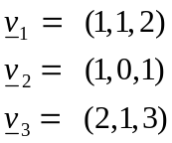

span R³. 6

Q.8 If A = 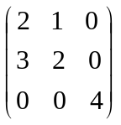 is a matrix

Find

(i) the eigenvalues of A 6

- the eigenvectors of A corresponding to any one of
its eigenvalues. 6

(iii) the rank and nullity of A. 8

TABLE OF LAPLACE TRANSFORMS

f(t) | F(s)
1
 | 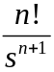
 | 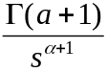
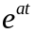 | 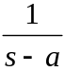
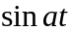 | 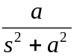
 | 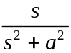
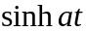 | 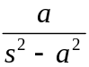
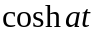 | 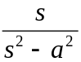
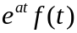 | 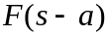
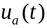 | 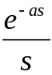
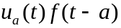 | 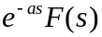
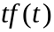 | 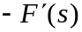
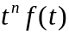 | 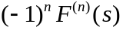
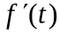 | 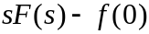
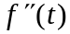 | 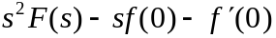
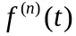 | 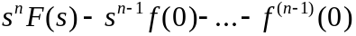
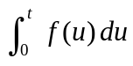 | 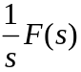
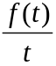 | 